Automatic Database Backup to Google drive using cybrosys module
From the link: https://apps.odoo.com/apps/modules/16.0/auto_database_backup/

1- install the module dependencies in your python venv
first make sure to activate your environment
source ./path_to_venv/bin/activate

then install the dependencies

pip install dropbox
pip install pyncclient
pip install nextcloud-api-wrapper
pip install boto3
pip install paramiko
2- install the module in the odoo database and Go to Setting --> Technical --> Backup Configuration to configure backups
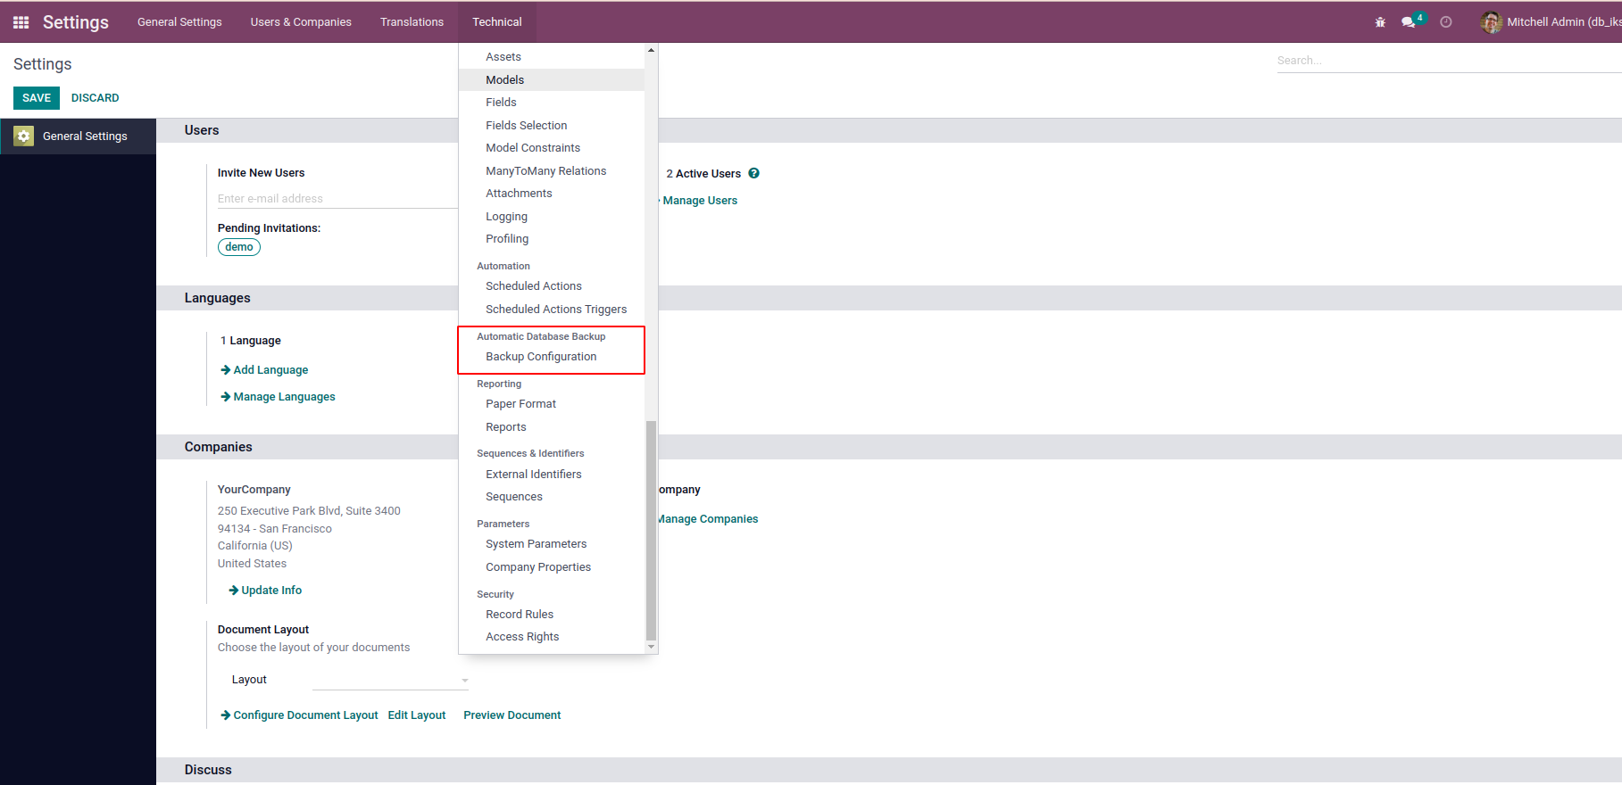
3- Create New Database Backup Configuration
Enter the Database Name and Master Password. Specify google drive a the Backup Destination.

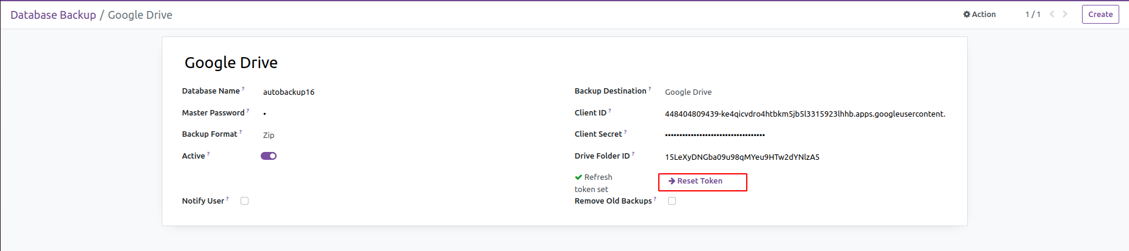

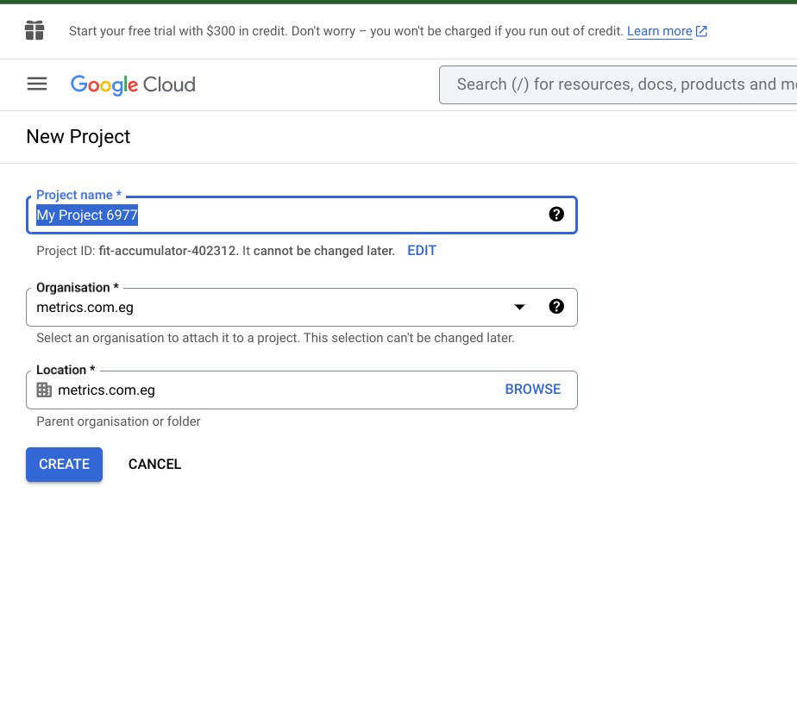
4- to give access to the module to the module to your google drive you need first to create a google cloud project by following the instructions here https://developers.google.com/workspace/guides/create-project

5- the make sure that you choose the created project and from APIs and services
choose enabled APIs and services and search for google drive api and enable it
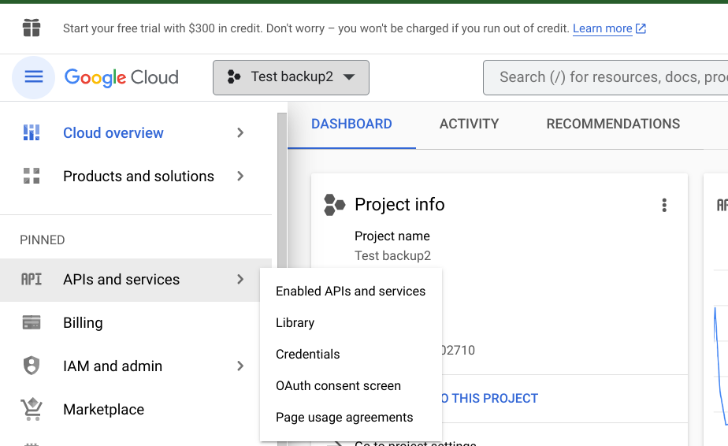

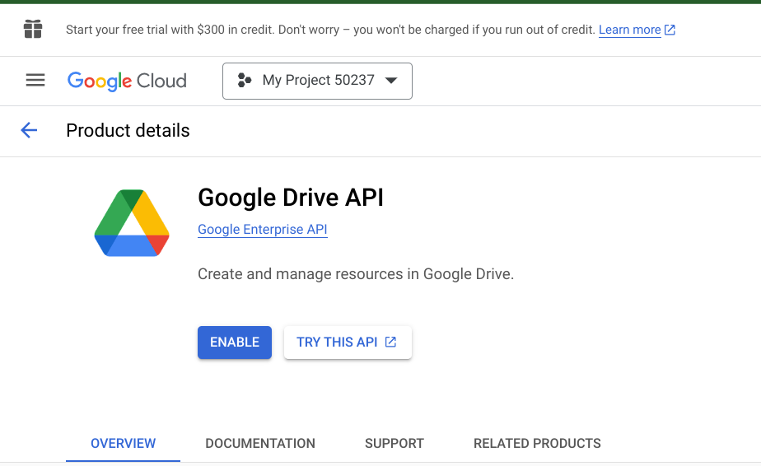

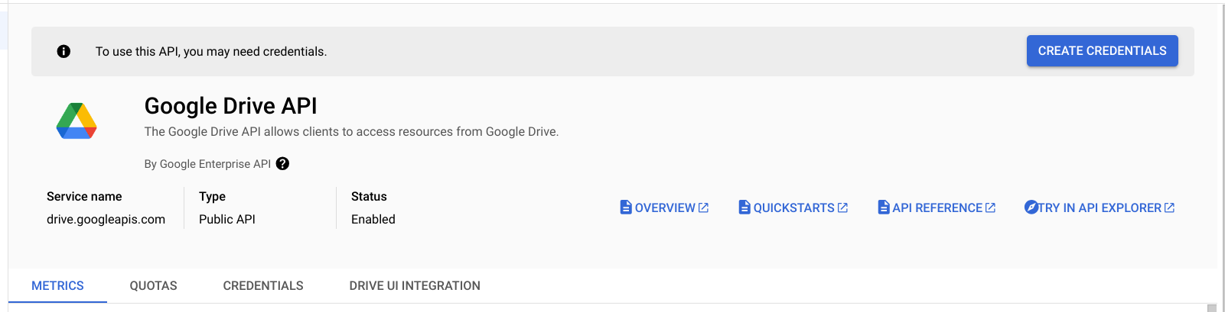
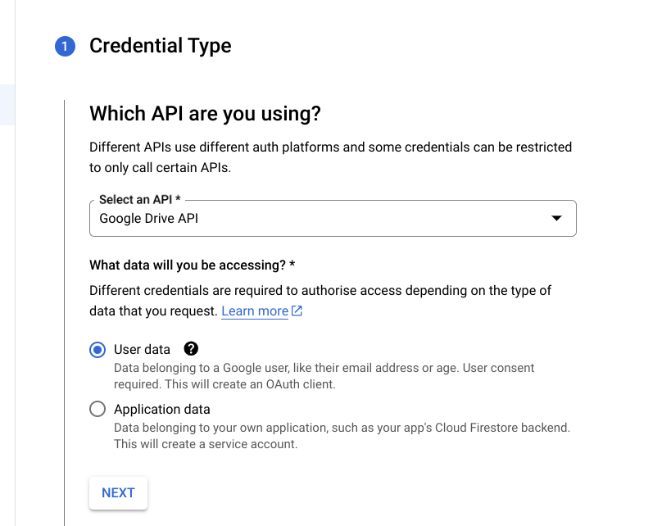
6- press create credentials and choose as the following pic

7- continue filling the data

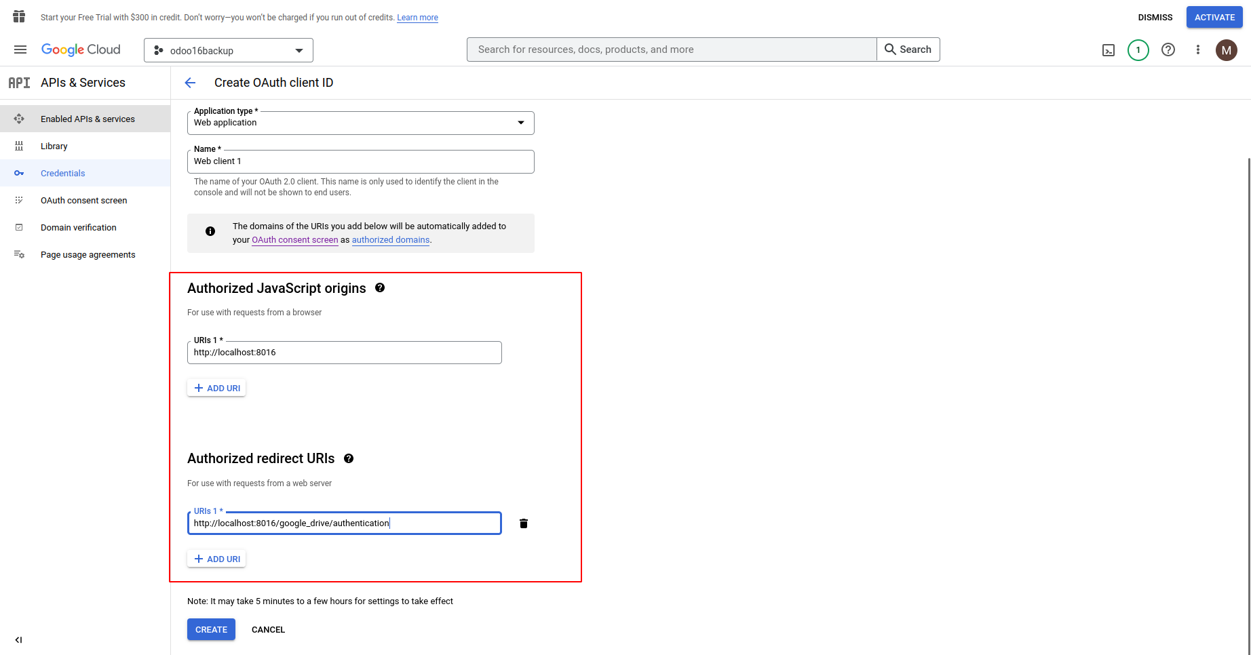

8- at the end you will be provided with the client id an client secret continue configuring the database backup with them
** notice that the folder id is the “1F36canhpRQLu_kF2vCM69X5MBkUjh392” as in
https://drive.google.com/drive/folders/1F36canhpRQLu_kF2vCM69X5MBkUjh392

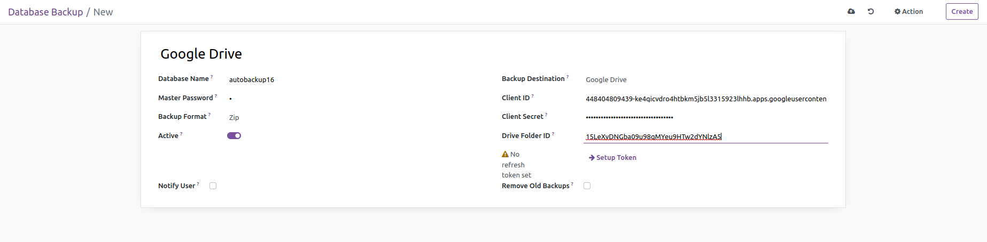

9- click setup token and save
10- in odoo from settings> technical > scheduled actions : find Automatic Database Backup and activate it
*** here also you can change how regular backups are created
